**G.SATHISH**

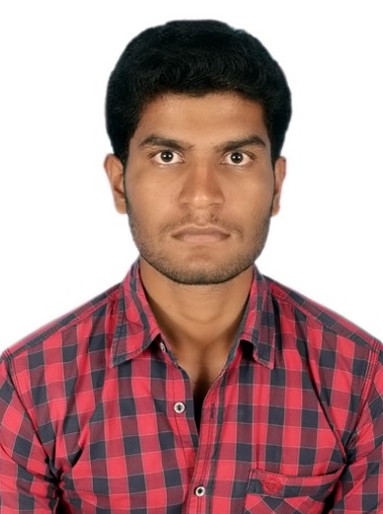

**Email :gksakthi@yahoo.com**

**Mobile : +91-9916086082**

**+91-9066809099**

**Objective:**

To be a professional where I can prove my excellence and performance, fulfil the expectations of my superiors.To learn all the upcoming techniques in whatever field I am into.

|  |  |  |  |  |  |
| --- | --- | --- | --- | --- | --- |
| **Examination** | **Discipline/**  **Specialization** | **School/college** | **Board/**  **University** | **Year of Passing** | **Percentage** |
| **B.E** | Computer Science and Engineering | SRG Engineering College, Namakkal. | Anna University | 2014 | 65% |
| **HSC** | Bio-Mathematics | Concordia Higher Secondary School, Barugur. | State Board | 2010 | 57% |
| **SSLC** | SSLC | Government Higher Secondary School,Madarahalli. | State Board | 2008 | 50% |

**Educational Qualifications:**

**Area of interest**

* Database Management System.
* Java Programming.

**Technical Proficiency**

* Programming Language: Sql, PL/Sql**,** Java,Html.
* Operating System : Windows XP, Windows 7,Windows 8.1

**Project Title:**

I have executed Project on **“Face-To-Face Proximity Estimation Using Bluetooth On Smartphones**”.

**Certification Courses:**

* Certification in Oracle Database SQL from Velox Software, Bangalore, 2014.
* Certification in Oracle Database PL/SQL from Velox Software, Bangalore, 2014.

**Work Experience:**

* Worked as Software Trainee and Developer in Riseon Technology Pvt Ltd ,Bangalore from Aug 2014-Jan2015.

**Co-Curricular Activities:**

* Participated in the **‘Cloud Computing’** workshop in **PSG College of Technology**, Coimbatore.
* Presented a paper titled **‘Brain controlled car for disabled using artificial intelligence’** in **Government College of Technology**, Coimbatore.
* Participated in the **‘Android’** workshop in **Vellore Institute of Technology**, Vellore.

**Extra-curricular Activities:**

* **Role of placement co-ordinator** in College Level.
* As a **Class Representative** in College Level.

**Industrial visit:**

* **Chips software** at **Kerala** in **2012.**
* **ISRO** at **Bangalore** in **2013.**

**Personal Profile:**

* Date of Birth and Age **:** 05Jun1992 and 22
* Parent’s Name **:** Mr. M.Govindaraji & Mrs.G.Kamala
* Gender **:** Male
* Language **:** English,Tamil,Telugu,Kanad
* Nationality **:** India
* Hobbies **:** Drawing, Listening Music, Playing Cricket
* Address **:** 4-2,Parandapalli Pudhur,Parandapalli,

Pochampalli, Krishnagiri, Tamil Nadu-635206

**Declaration:**

I hereby declare that all the above furnished information about myself are true to the best of my knowledge and belief.

Thank you,

**(G.SATHISH)**